Erick Grant

CST-239

January 22, 2023

Activity 1

This is also available in an easier to read format at

<https://esyew.notion.site/Erick-Grant-Activity-1-Turn-in-d8106476a5644d108ea12a1e6ad57941>

Part 1 Tools Installation and Validation

Code

package app;  
  
public class HelloWorld {  
private static void sayHello(String name) {   
System.out.println("Hello my name is " + name);  
}  
 public static void main(String[] args) {  
   
 sayHello("John Doe");  
  
 }  
  
}

Part 2

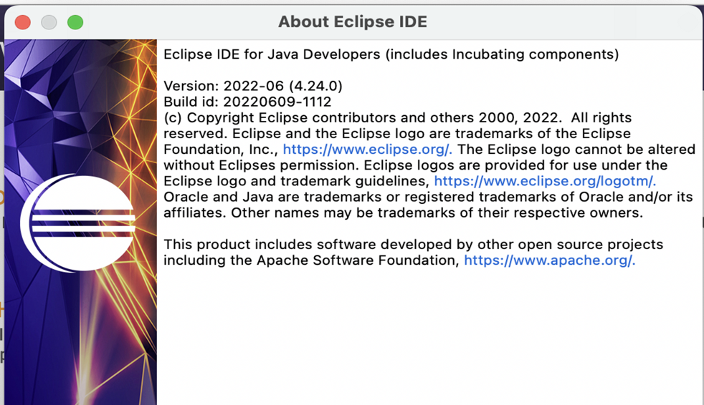

**Part 2** Designing, Coding, and Documenting a Person Class

**Part 2 Theory of Operation**

Person class accepts name, idNumber, age, and emailAddress, this saves each variable in a private manner. The getters are dedicated classes, and the setters are part of the Person(…) class. The increaseAge(int amount) class takes *amount* and adds it to the person.age variable. The sendEmail does not change variables, however it does return a “mailto:” URI, which is typically not used, except for error handling. It should begin a email in the user’s default email client. Main creates a person object with some default data, then it increases the age property by two years. Then it attempts to have the user compose a email so they can contact the Person.

Console Explanation (Pseudo Code

// Paragraph  
// * First line of console states of initial age & name, using current parameter was 37.   
 System.out.println(name + " is " + age + " years old.\n");  
  
 //* Enter a blank line  
System.out.println();  
  
 //* Testing line, outputs new age to console.  
 //Inside of the increaseAge(amount) class  
System.out.println(" TEST: I am in increaseAge()");  
 //Inside of increaseAge(amount) class  
 //After addition of age and amount, this shows that the math was done properly.   
System.out.println(" TEST: The new age is: " + age);  
  
  
//Back in main  
  
//Add a blank line, for readability  
System.out.println();  
 // Following in printed from main, documenting the increase of age, shown to the user.  
John Doe is now 39 years old.  
  
//Add a blank line, for readability  
System.out.println();  
  
  
//From sendEmail  
  
 //TEST: Hello I am in sendEmail(), showing that the class is excucuted.   
 System.out.println(" TEST: Hello I am in sendEmail()");  
 //There may be error messages that are shown in console, however these should not appear under successful email composing.   
 //WILL NOT APPEAR NORMALLY   
System.out.println("Please enter this into a web browser, to create the email."); // This tells the user how they can use java to create the message, however it was unable to open it automatically.   
 //Prints out a URI that should be pastable into Chrome or other web browsers.  
 System.out.println(message); //This is also used for troubleshooting  
  
  
/* Sentence that explains this without code.  
 * Prints new age and name to console,   
 * In email body that is generated, gives name, age, and ID Number;  
 * this was done using Desktop.action.mail which is java's mail handling system  
 * Opens URI with "mailto:" in system, which should open outlook or another mail application.   
*/

Part 3: Designing, Coding, and Documenting a Race Car Class

Part 4: Using the debugger

First breakpoint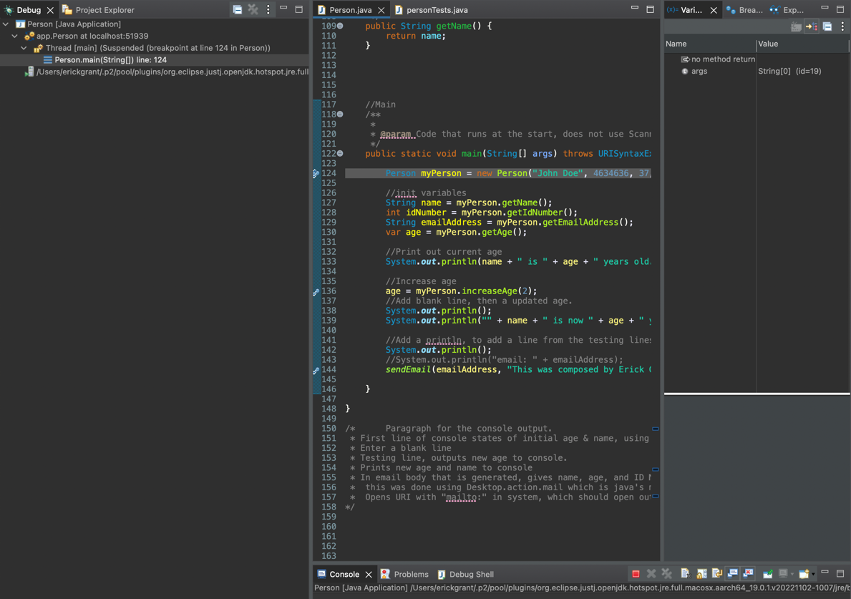

**Research Questions**

1. Your text discusses a relationship between classes called “association.” Think about the class project you are currently designing. What associations exist between the Salable and the Shopping Cart class? What is the multiplicity of these associations?

Both the shopping cart and the car class contain multiple instances of the same classes, ie four sets of tires and howeever many products in the inventory and cart. In addition, products also have their own sub classes for each kind that have data that is more specific to the type of item, such as a power up boost level. Both use cases support only one sub class per item.

1. What is meant by the statement “class abstraction is the separation of class implementation from the use of a class”? Illustrate your answer with a Java class.

Class abstraction helps allow for both data hiding, and better scalability; it allows for one piece of code to be used for numerous different objects. This is called encapsulation, and allows a user to create an object without knowing as much about the backend, which helps improve security.

References

Part 2

Anić Banić, R. (2015, July 2). *How to replace space with %20 in Java*. Stack Overflow. Retrieved January 18, 2023, from https://stackoverflow.com/questions/31610444/how-to-replace-space-with-20-in-java#31610480

sfussenegger. (2014, March 1). *Java: Open default mail application and create new mail and populate to and subject fields*. Stack Overflow. Retrieved January 18, 2023, from https://stackoverflow.com/questions/2357895/java-open-default-mail-application-and-create-new-mail-and-populate-to-and-subj#2357924